<https://seekerproject.com/>

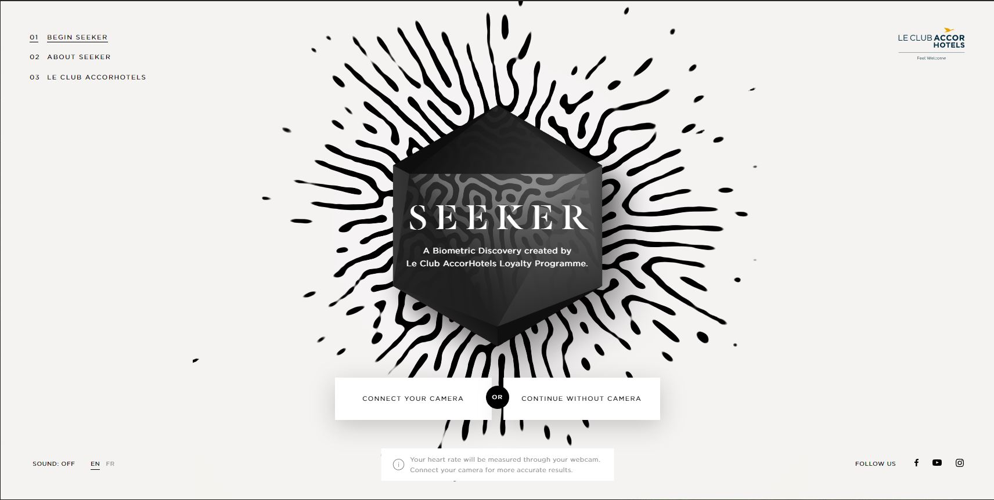



This concept really intrigued me since it was about immersion, augmented reality, and virtual reality. The site also takes several questions and pairs you with one of their destinations. A really interesting idea.

One this I did like about this site was the way their menus and content is laid out. In our research about disabilities, the researcher had you put your fingers in a circle like a telescope and look at the site. If you do this on this site, you can tell they have sectioned off areas just for this purpose. Upper left is the menu, the content in the center, then other buttons and link in the corners.

This whole website is very consistent on their layout, and everything is where you would expect it, content in the center, menu, links, and other information around the corners.



This screenshot starts the long, or it felt that way, process of determining your personality so they can suggest a destination, there were three different screens each showing you a picture that you would drag to the left for yes you like that, or to the right, meaning no, you don’t really enjoy or like that.



This is the first screen of your personality test. There are several pictures which set the tone of your personality. Whether you are a calm, or adventurous type.

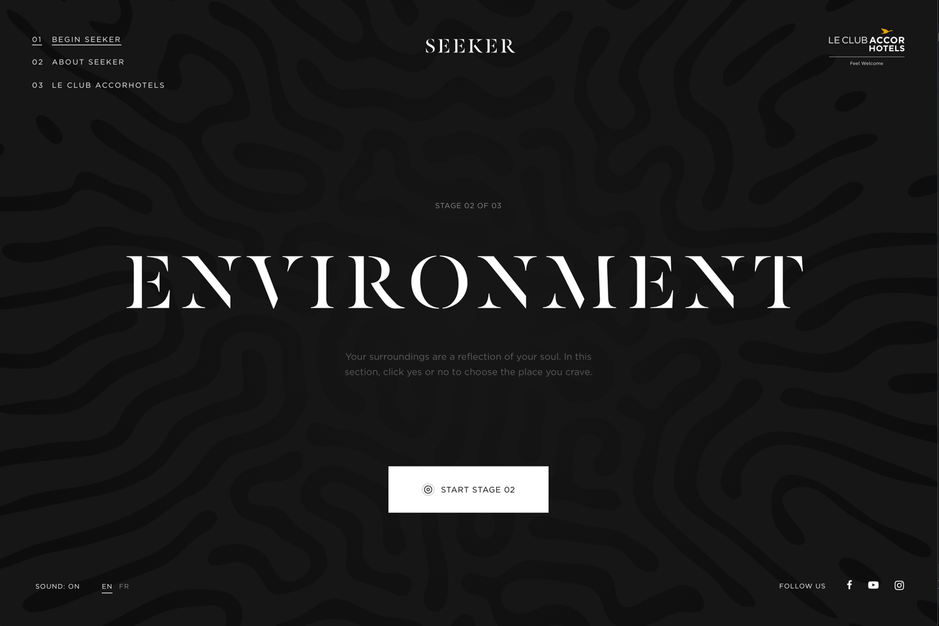



In this section, the user clicks on the surroundings they like or have an affinity for.

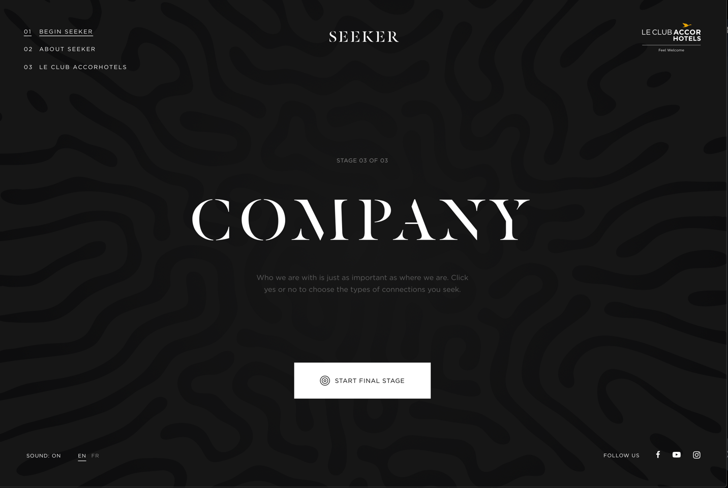



This last section is about the company you want to keep, who is important or not.



This is an example of what they wanted you to do for each section, the only issue I had with this, is if you were a keyboard user, you would not do this, it was drag and drop with the mouse. They should have used the left and right arrow key or ‘y’es or ‘n’o so keyboard users could do it.

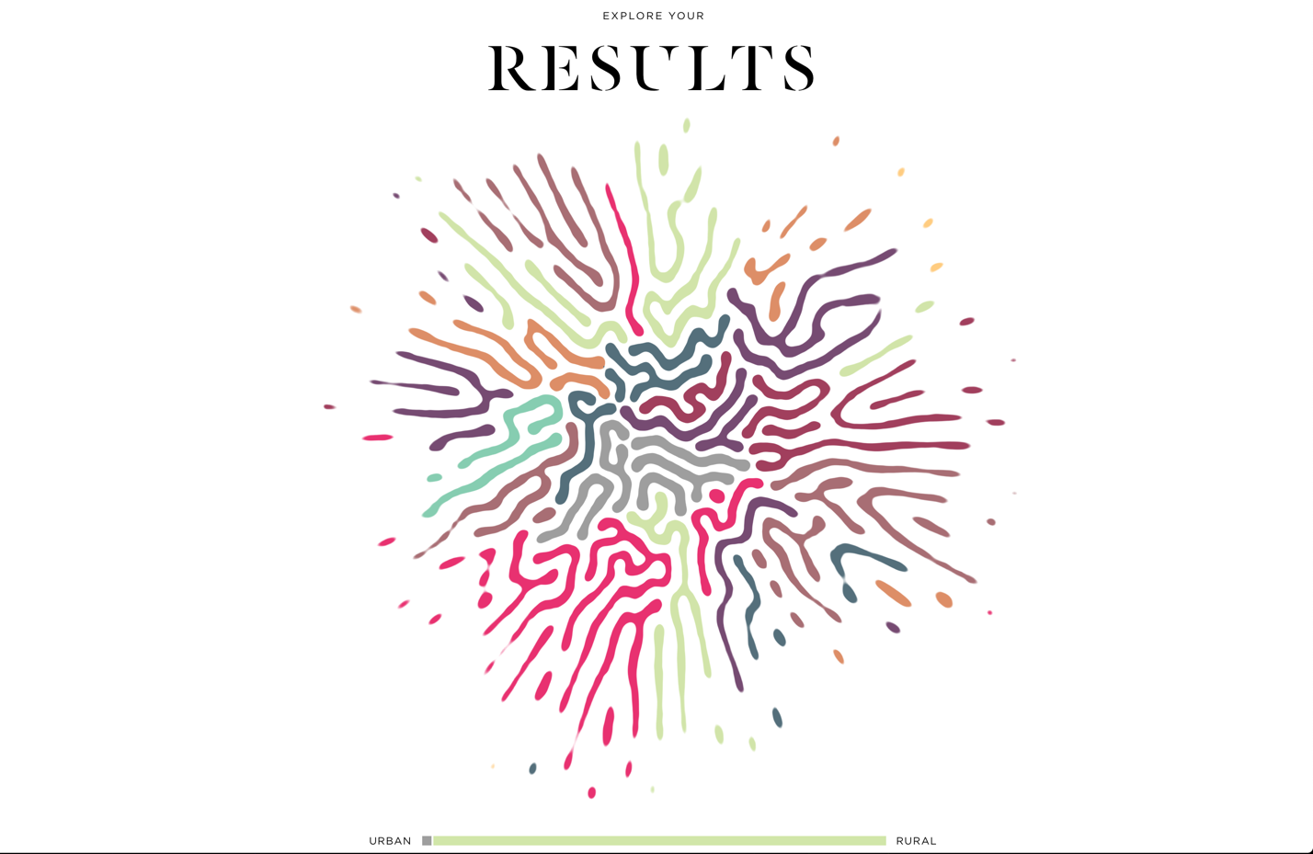

These are my results from the three sections.

In conclusion, the menu system was consistent at the upper left, the links were consistent in the lower right, even the sound and language selector was consistent being in the lower left. The name of the hotels was always in the upper right.

